Multi-Line Insurance Policy and Claims Management System
Salesforce Developer - Group Project Report
Prepared by: Praveen Prabakarn
Salesforce org: orgfarm-63e3e46d5b-dev-ed (Salesforce Developer Edition)
Project link: https://myskillwallet.ai/dashboard/skillwallet/module/salesforce-developer-nm-eng-6a69e3b28beabdd402737070/group-projects/6a6b1d37dafa0b21ea8a0900/Multi-Line-Insurance-Policy-and-Claims-Management-System-6ab601b2fa5e5219dc38104e?tab=2

About this report
This report documents the Salesforce configuration carried out for the Multi-Line Insurance Policy and Claims Management System project, using screenshots captured from the Developer Edition org while building the data model and the automation. Items that could not be completed because of missing prerequisites or insufficient privileges are listed honestly in the status table.

Work status
Item | Status
Policy object, Auto record type, Vehicle field set, VIN validation rule | Completed
Claim object with Approval Status and Claim Amount fields | Completed
AutoQuotingFlow (Get Vehicle RT ID, two screens, Create Draft Policy, varPolicyId) | Completed and Active (Customer, Policy Start Date and Policy State mappings pending missing fields)
Submission Automation Flow (Claim over 50000 -> approval) | Completed and Active (approval process still to be created)
Claim Approver Screen Flow | Partially built, not saved
Calculate Premium action / Update Policy With Premium | Pending - Premium field missing on Policy
Claim routing flow, Apex controller and tests, LWC dashboard | Pending - queues and Policy.Customer__c missing
Approval process, sharing rules, permission sets | Pending - requires administrator access

1. Data Model Setup - Policy and Claim Objects
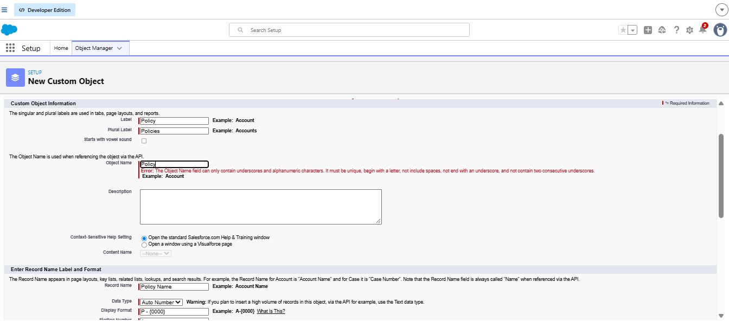
Figure: Creating the custom object Policy (Label: Policy, Plural: Policies, Record Name: Policy Name, Auto Number).
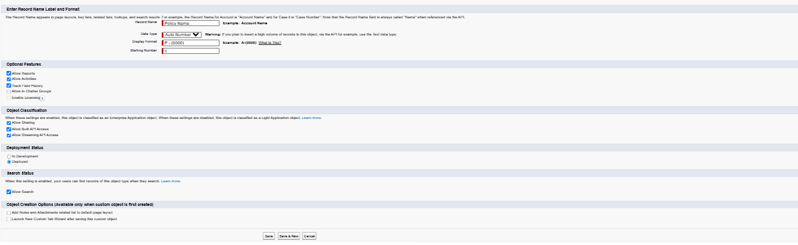
Figure: Object creation options and Save for the Policy object.
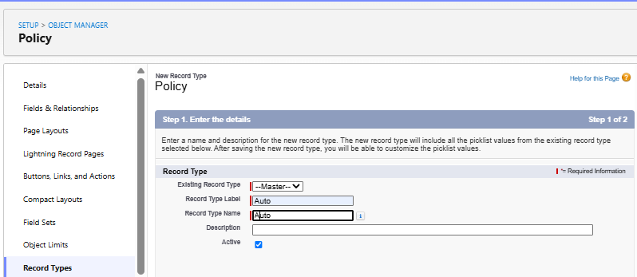
Figure: New record type 'Auto' on the Policy object.
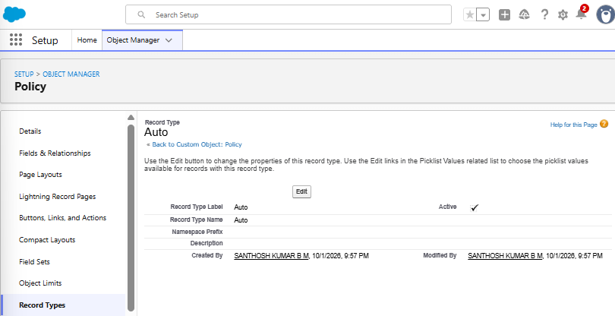
Figure: Auto record type created and Active (Record Type Name: Auto).
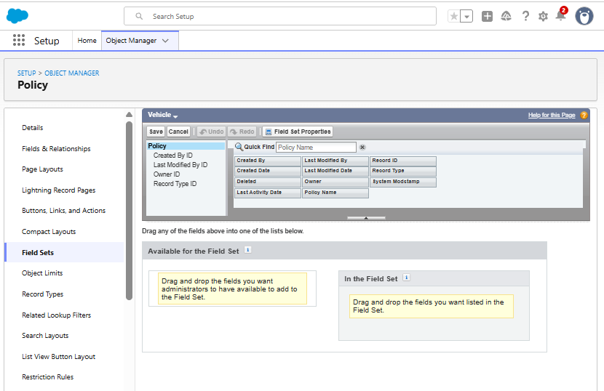
Figure: Field Set 'Vehicle' created on Policy - available fields.
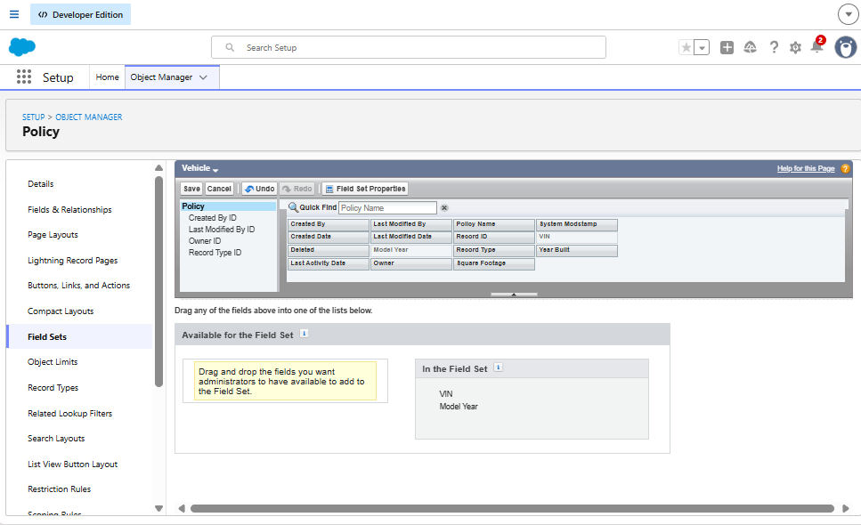
Figure: Vehicle field set with VIN and Model Year added.
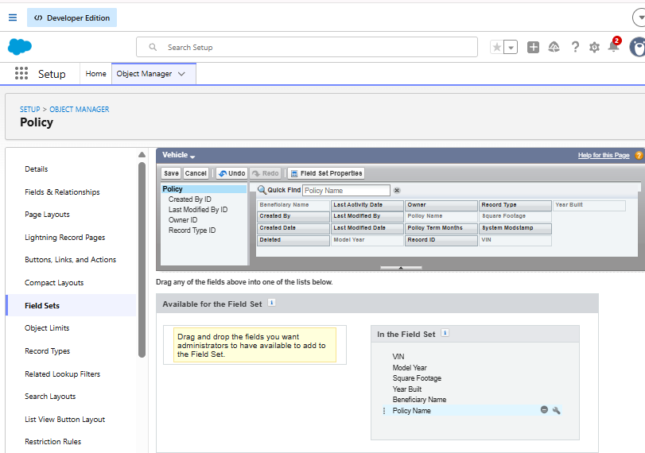
Figure: Vehicle field set containing VIN, Model Year, Square Footage, Year Built, Beneficiary Name, Policy Name.
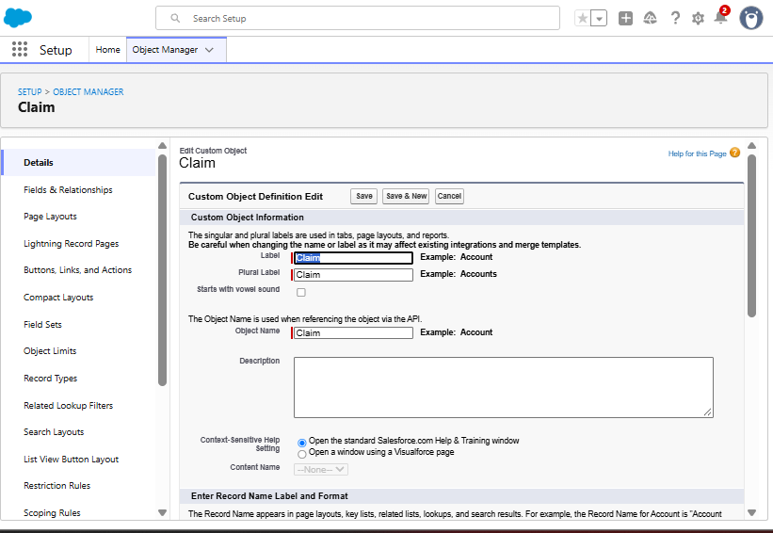
Figure: Creating the custom object Claim.
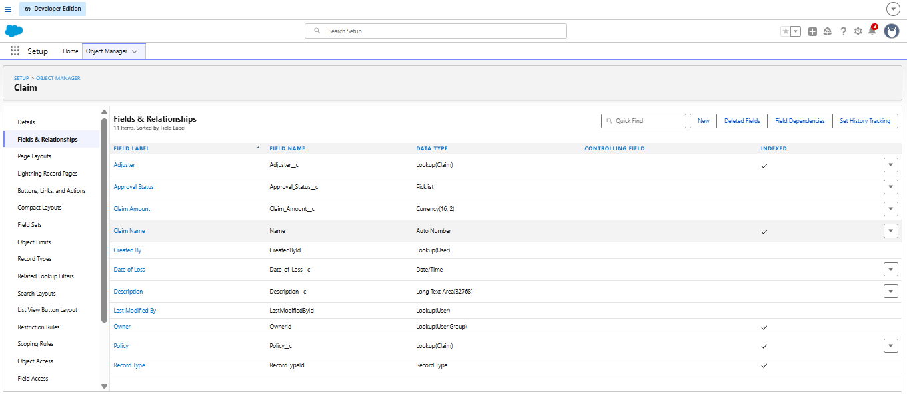
Figure: Claim fields: Adjuster, Approval Status, Claim Amount, Date of Loss, Description, Policy lookup, Record Type.
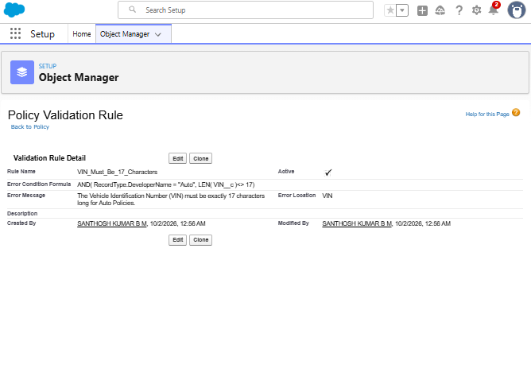
Figure: Validation rule VIN_Must_Be_17_Characters on Policy (Auto record type).

2. AutoQuotingFlow - Screen Flow
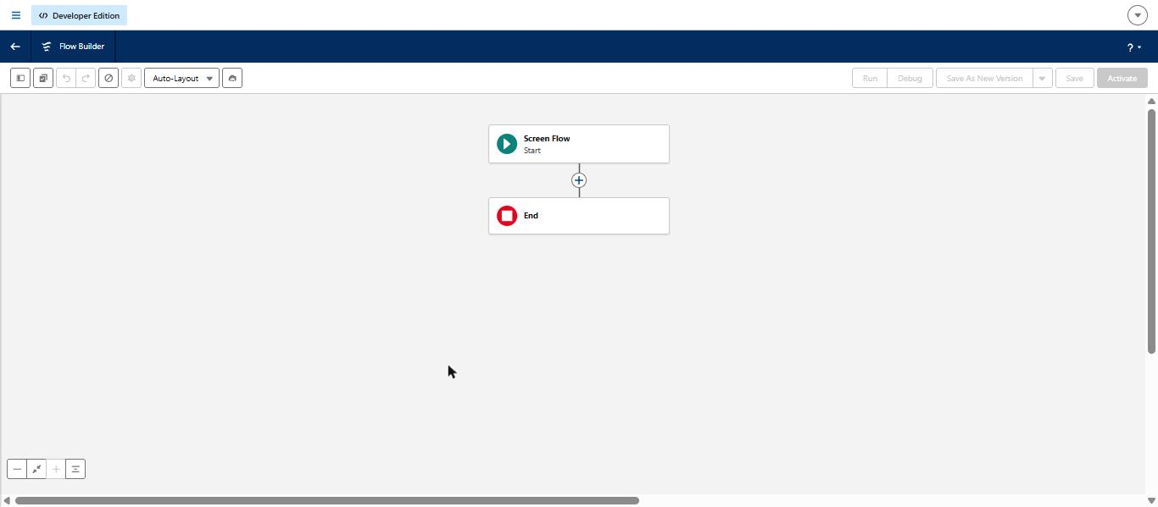
Figure: New Screen Flow canvas (Start and End) in Flow Builder.
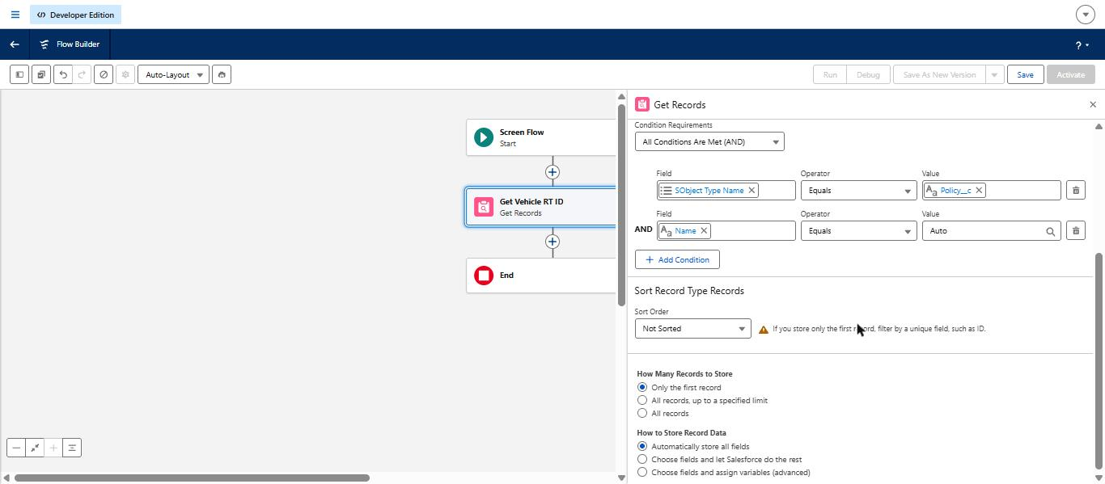
Figure: Get Vehicle RT ID - Record Type where SObject Type Name = Policy__c AND Name = Auto.
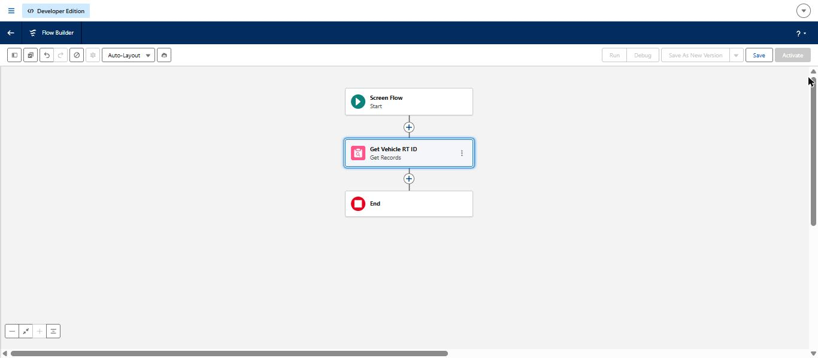
Figure: Get Vehicle RT ID element added after Start.
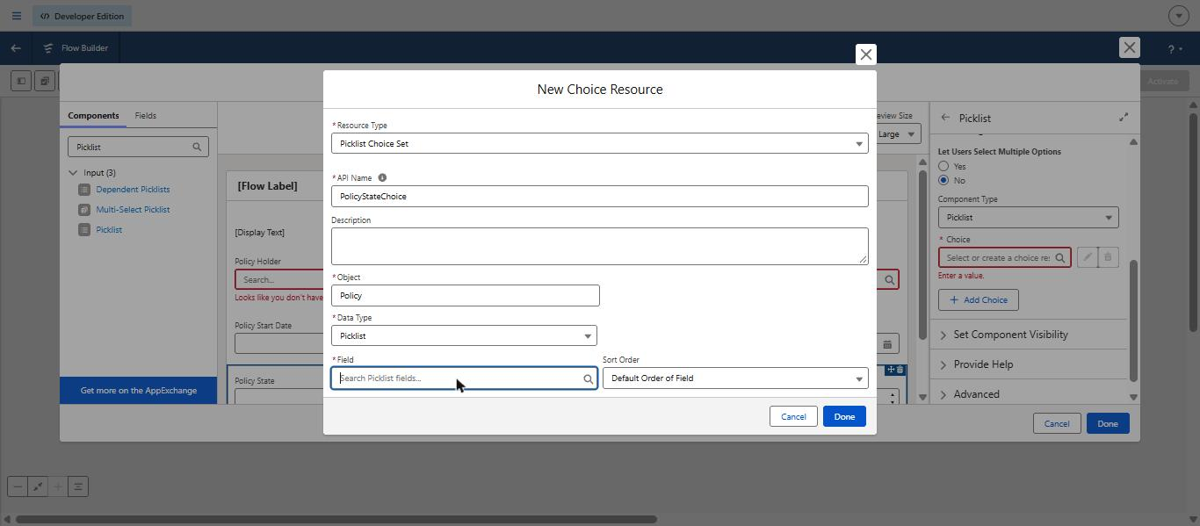
Figure: Limitation found: no Policy State picklist field exists, so the Picklist Choice Set could not be built.
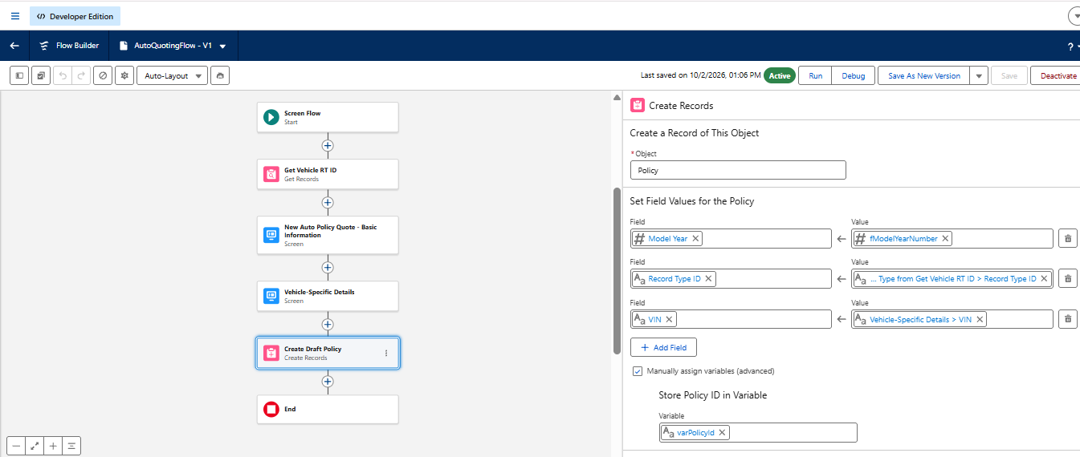
Figure: Flow canvas: Get Vehicle RT ID, Basic Information screen, Vehicle-Specific Details screen, Create Draft Policy.
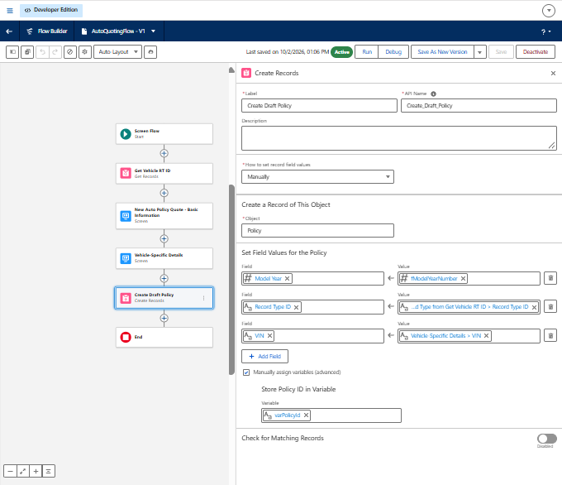
Figure: Create Draft Policy - manual field mapping and varPolicyId storage.
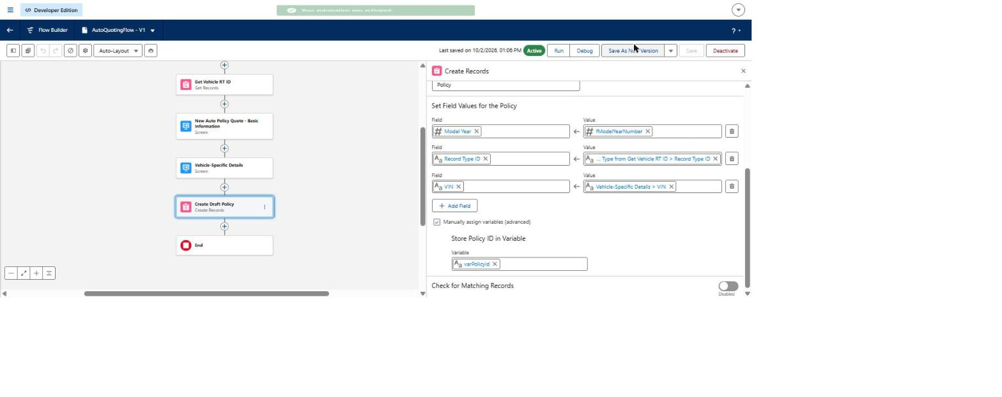
Figure: AutoQuotingFlow V1 saved and Active ('Your automation was activated').

3. Claims Automation and Environment Checks
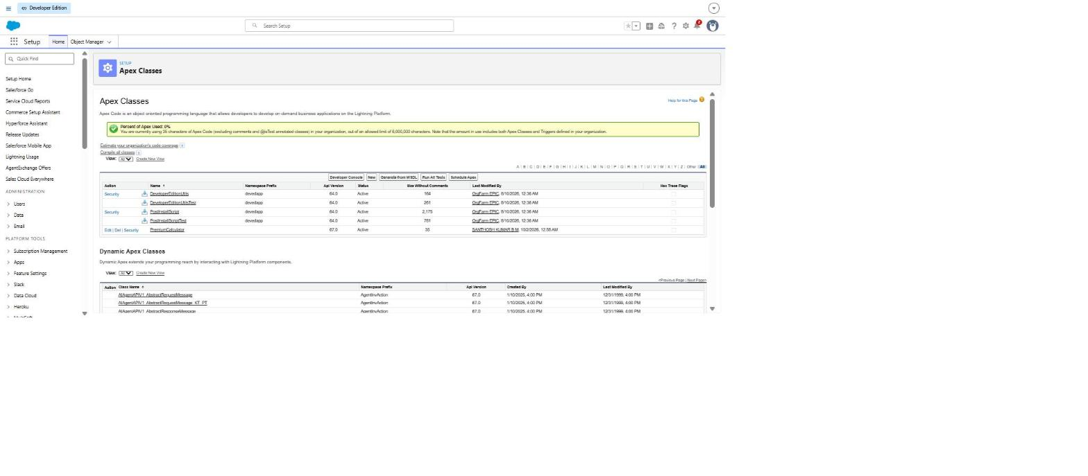
Figure: Apex Classes list - PremiumCalculator class is present in the org.
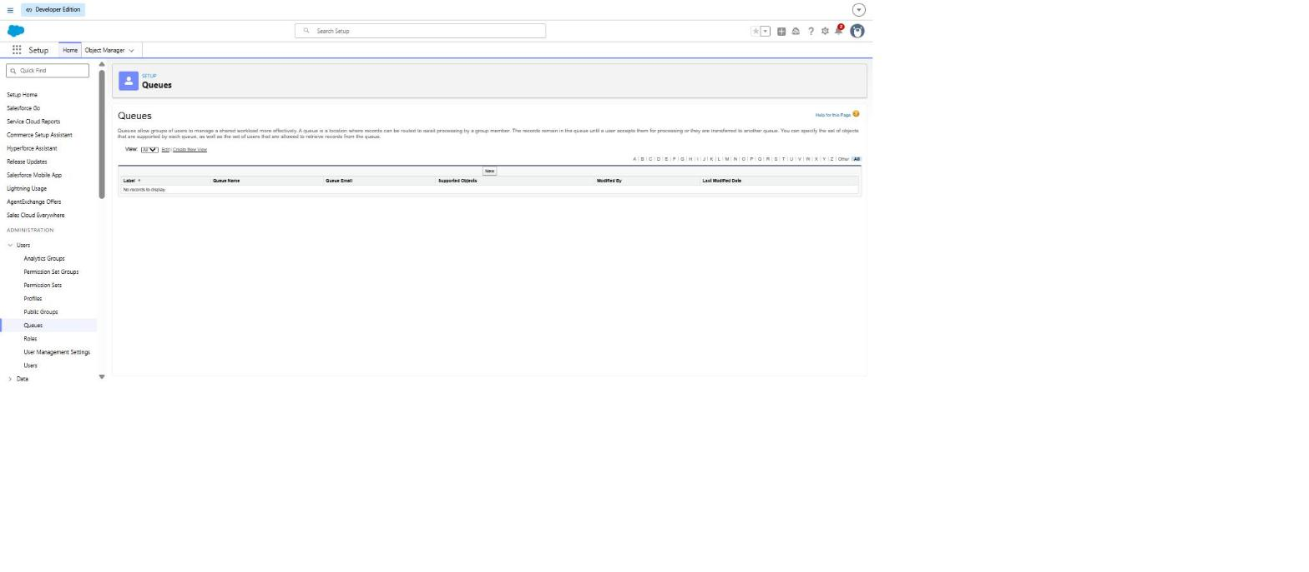
Figure: Queues page - no queues exist yet (needed for claim routing).
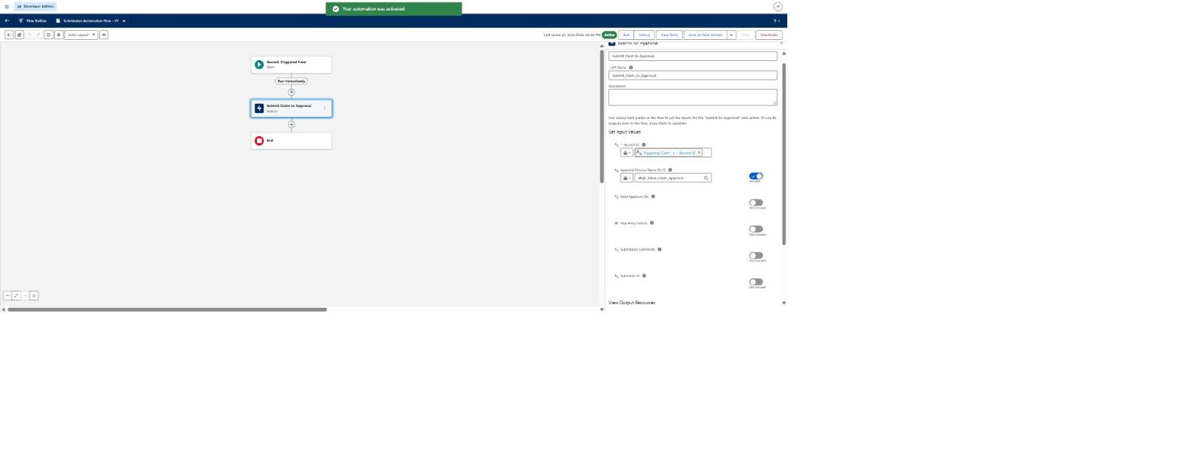
Figure: Submission Automation Flow (record-triggered on Claim) saved and Active, with the Submit Claim to Approval action.

